TEST TEMPLATE

1. Filter Navigator 🡪 Test Template
2. Create New Test Template

Name – Template 1

1. Add the Test Steps that must be in the Template

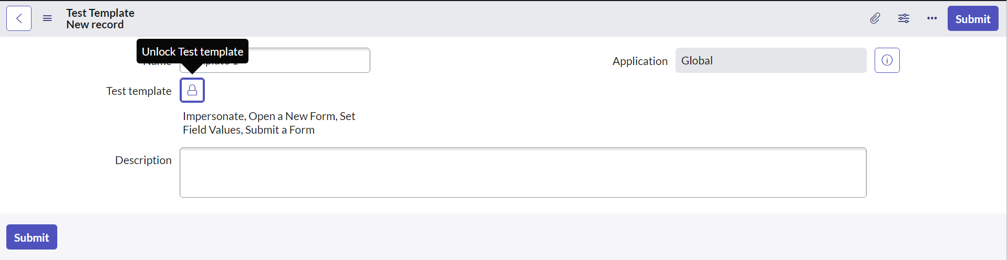

1. To use this Test Template, we need to create a Test Case

Create a New Test Case –

Name – Test Template

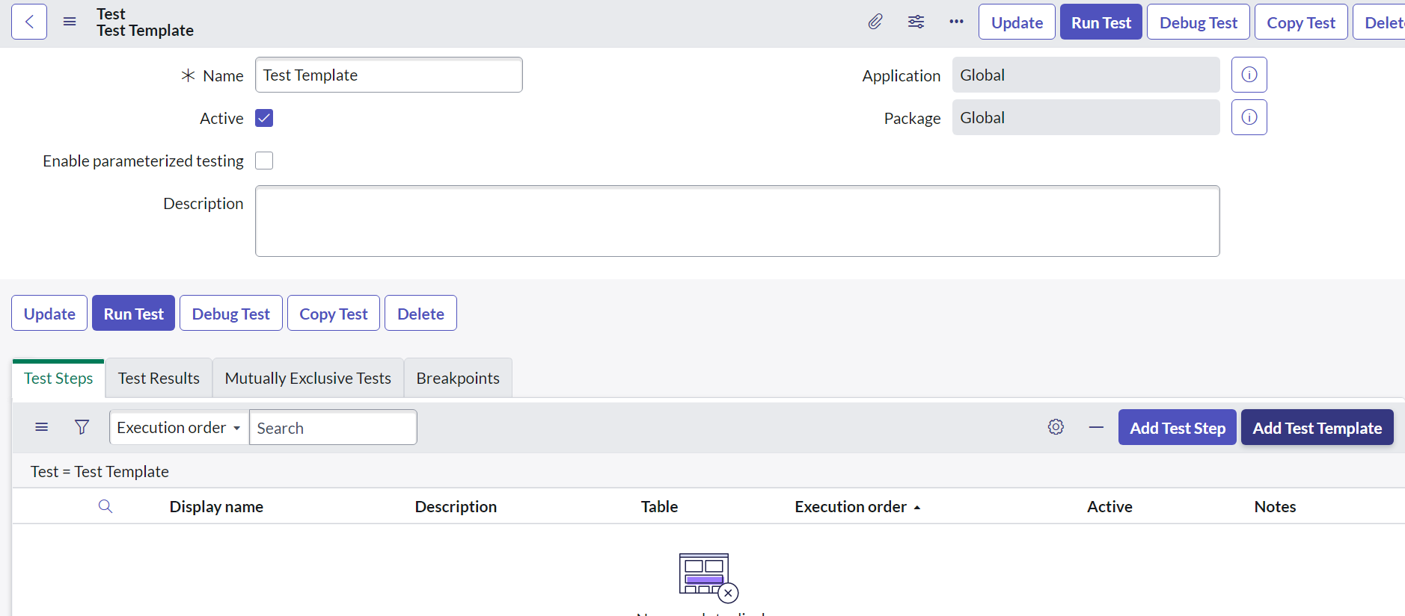

**Add Test Template**

1. Choose the Test Template

Here we also need to choose the Table

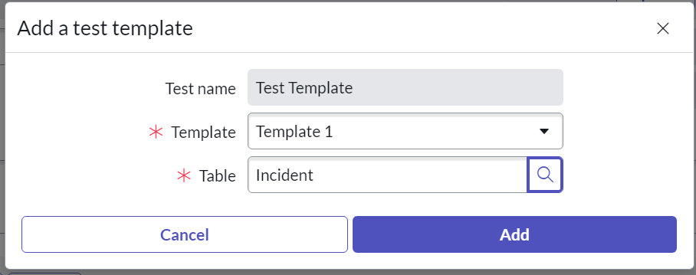

1. Now we see that all the Test Steps from the Test Template is imported

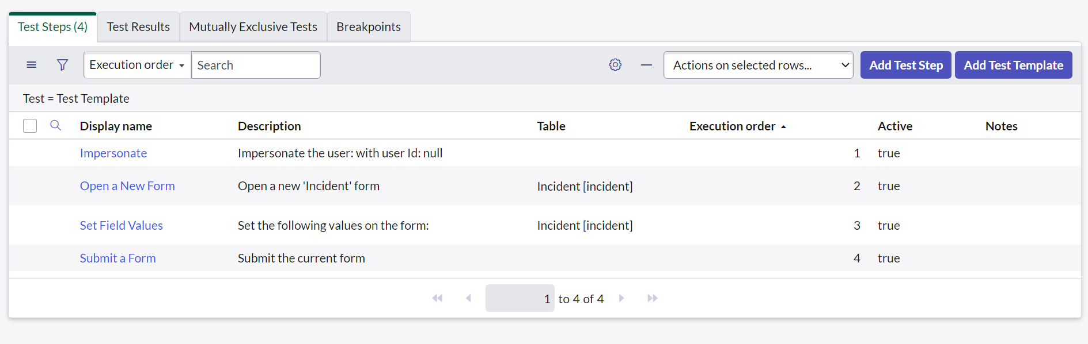

1. We need to modify the Impersonate

We must add the User who needs to be Impersonated

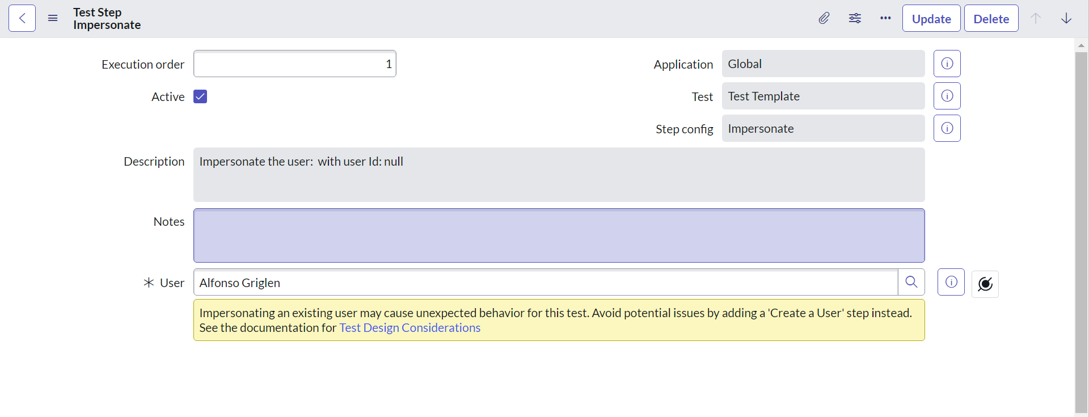

1. Now we need to modify the Set Field Values

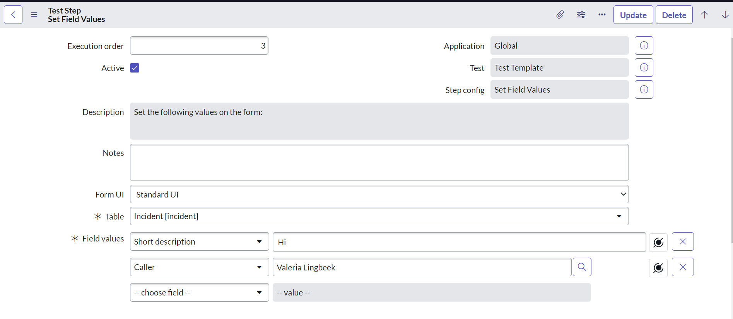

1. Run Test

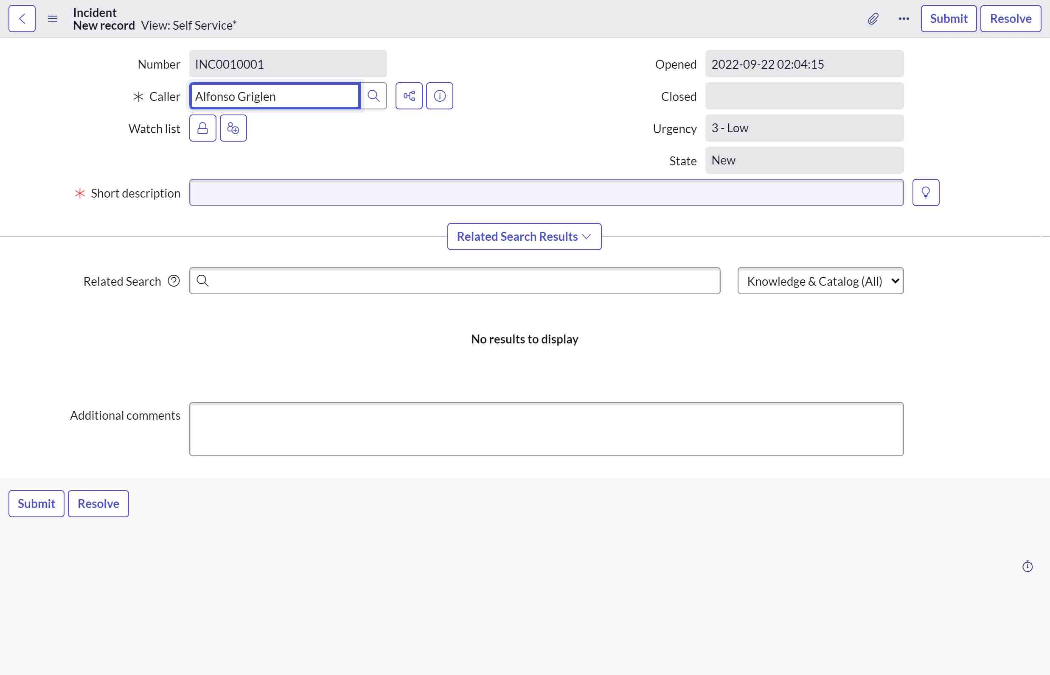

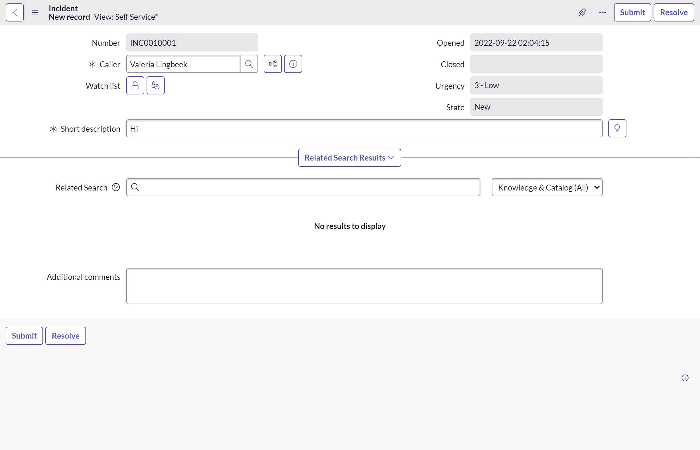

* Adding Multiple TEST TEMPLATES IN ONE TEST CASE